Case Study Analysis Report
Assignment Title: Intelligent AI-Based Smart Aquaculture Disease Prediction and Feed
Optimization System
CO2-ASSESSMENT TOOL - 2

Submitted By
Name: SHAKTHIVEL R
Register Number: 192524325
Course: Software Engineering
Course Code: CSA1017
Assignment Title: Case Study Analysis
Department: B.Tech (AI &DS)



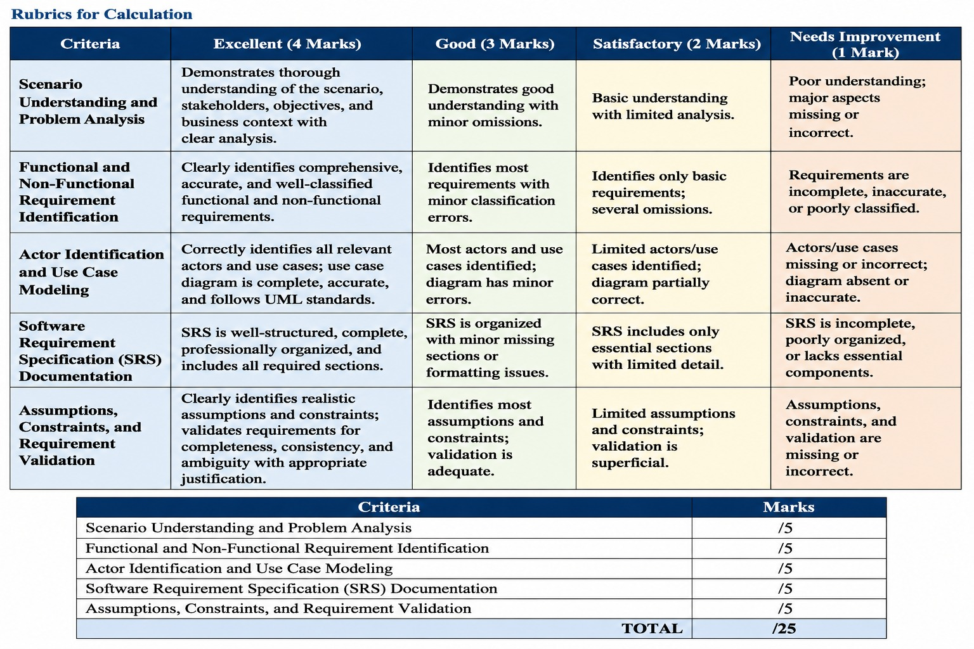

CO2 ASSESSMENT TOOL 2 – ARCHITECTURE DESIGN ASSIGNMENT
Intelligent AI-Based Smart Aquaculture Disease Prediction and Feed Optimization System

1. SYSTEM REQUIREMENTS ANALYSIS
1.1 System Objectives
The Intelligent AI-Based Smart Aquaculture Disease Prediction and Feed Optimization System is designed to improve fish farming through IoT, Artificial Intelligence, Machine Learning, and cloud technologies.
The system continuously monitors aquaculture environmental conditions and analyzes the collected data to predict possible fish diseases and optimize feeding activities.
The main objectives of the system are:
- To continuously monitor water quality and environmental conditions.
- To collect real-time data using IoT sensors.
- To identify abnormal water-quality conditions.
- To predict potential fish diseases at an early stage using AI and Machine Learning.
- To determine the optimum quantity and timing of fish feed.
- To reduce feed wastage and unnecessary feeding costs.
- To improve fish health, growth, and survival rate.
- To provide real-time alerts and recommendations to farmers.
- To store historical data for analysis and future predictions.
- To provide a scalable platform that can support multiple farms and ponds.
1.2 Functional Requirements
1. User Registration and Authentication
The system shall allow farmers and administrators to register and securely log in to the system.
2. Farm and Pond Management
The system shall allow users to add, update, and manage information about farms, ponds, fish species, and fish populations.
3. IoT Sensor Monitoring
The system shall collect real-time environmental data using IoT sensors such as:
- Water temperature
- pH level
- Dissolved oxygen
- Turbidity
- Ammonia level
- Water level
4. Real-Time Data Processing
The system shall receive, validate, preprocess, and analyze sensor data in real time.
5. Disease Prediction
The AI/ML module shall analyze environmental and historical fish-health data to predict the probability of fish diseases.
The system shall provide disease-risk classifications such as:
- Low Risk
- Medium Risk
- High Risk
6. Feed Optimization
The system shall recommend the appropriate quantity and timing of feed based on:
- Number of fish
- Average fish weight
- Fish growth rate
- Water temperature
- Fish health
- Previous feeding history
- Environmental conditions
7. Alert and Notification
The system shall generate alerts when critical conditions are detected, such as poor water quality or high disease probability.
Notifications may be sent through:
- Mobile push notifications
- SMS
- Email
8. Dashboard
The system shall provide a dashboard displaying:
- Real-time sensor readings
- Water-quality status
- Disease prediction
- Disease probability
- Feed recommendations
- Feeding history
- Alerts
- Historical trends
9. Data Storage
The system shall store user information, farm information, sensor readings, feeding records, disease predictions, alerts, and historical data.
10. Report Generation
The system shall generate reports related to:
- Water quality
- Fish health
- Disease predictions
- Feed consumption
- Feed optimization
- Historical sensor trends
1.3 Non-Functional Requirements
Performance
The system should process sensor data and generate predictions with minimum delay. Critical alerts should be delivered quickly.
Scalability
The system should support an increasing number of farms, ponds, sensors, users, and data records without major architectural changes.
Security
The system should protect user accounts, farm information, sensor data, and AI results using authentication, authorization, encryption, and secure APIs.
Reliability
The system should continue functioning correctly even when temporary sensor, network, or service failures occur.
Availability
The system should provide continuous access to monitoring, predictions, dashboards, and critical alerts.
Maintainability
The system should be modular so that individual components such as the disease prediction model or feed optimization model can be modified independently.
Usability
The system should provide a simple and user-friendly interface that allows farmers to understand sensor readings, disease risks, and feed recommendations easily.
Interoperability
The system should support integration with different IoT devices, mobile applications, cloud services, notification services, and external APIs.
1.4 Key Quality Attributes
The major quality attributes influencing the architecture are:
- Scalability
- Security
- Performance
- Reliability
- Availability
- Maintainability
- Usability
- Interoperability
These attributes require a modular, scalable, secure, and fault-tolerant architecture.

2. SELECTION OF SUITABLE SOFTWARE ARCHITECTURE
2.1 Selected Architecture
The proposed system uses a Hybrid Layered Architecture with Event-Driven IoT Processing and AI/ML Services.
The architecture combines the advantages of:
- Layered Architecture
- Client-Server Architecture
- Event-Driven Architecture
- AI/ML-based services
- Cloud-based data storage
2.2 Architectural Layers
The proposed system consists of the following major layers:
1. Presentation Layer
This layer provides the user interface through a web application or mobile application.
2. Application Layer
This layer manages authentication, farm management, pond management, feeding management, alerts, and API requests.
3. IoT and Data Processing Layer
This layer collects data from sensors, validates the data, performs preprocessing, and transfers the information for further analysis.
4. AI/ML Layer
This layer contains the disease prediction model and feed optimization model.
5. Data Layer
This layer stores real-time and historical information in databases and cloud storage.
6. External Services Layer
This layer integrates external services such as SMS, email, push notifications, weather APIs, and other required services.
2.3 Justification for Selecting the Architecture
The hybrid architecture is suitable because the proposed system handles multiple types of workloads.
IoT sensors continuously generate environmental data, while AI models analyze this data to predict diseases and optimize feeding.
The layered architecture separates the presentation, application, processing, AI, and data responsibilities. This improves maintainability and makes the system easier to modify.
The event-driven approach is suitable for real-time sensor monitoring because sensor events can automatically trigger data processing, disease prediction, and alerts.
The AI/ML components are separated from the main application so that the models can be updated or retrained without redesigning the complete system.
Cloud-based storage provides scalability for increasing sensor and historical data.
Therefore, the selected hybrid architecture provides a suitable balance between scalability, performance, reliability, security, and maintainability.

3. COMPONENTS AND THEIR INTERACTIONS
3.1 IoT Sensors
IoT sensors are responsible for collecting real-time environmental information from the aquaculture farm.
The sensors measure parameters such as temperature, pH, dissolved oxygen, turbidity, ammonia, and water level.
The collected data is transferred to the IoT gateway.
3.2 IoT Gateway
The IoT gateway acts as an intermediate communication device between sensors and the cloud or application server.
It receives sensor readings and forwards them to the data processing system using communication protocols such as MQTT or HTTP.
The gateway may also temporarily store data when network connectivity is unavailable.
3.3 Data Validation and Preprocessing Module
This module checks the incoming sensor data before sending it to the AI models.
Its responsibilities include:
- Checking missing values
- Removing invalid readings
- Filtering noise
- Detecting abnormal values
- Normalizing data
- Adding timestamps
Clean and validated data is then stored and forwarded for AI analysis.
3.4 Disease Prediction Module
The disease prediction module uses AI/ML techniques to analyze environmental conditions and historical fish-health data.
The model identifies patterns associated with possible diseases.
The output includes:
- Disease name or category
- Disease probability
- Risk level
- Early warning
3.5 Feed Optimization Module
The feed optimization module determines the recommended quantity and timing of feed.
The module considers fish population, fish size, growth rate, water temperature, fish health, previous feeding history, and environmental conditions.
The output provides a recommended feeding quantity and schedule.
This helps reduce overfeeding, underfeeding, feed wastage, and operational costs.
3.6 AI Recommendation Engine
The recommendation engine combines the results generated by the disease prediction and feed optimization models.
It converts AI predictions into practical recommendations for the farmer.
For example, if disease risk is high, the system may recommend checking water quality and adjusting feeding conditions.
3.7 API Gateway
The API Gateway acts as the main communication point between the frontend applications and backend services.
It manages:
- API requests
- Authentication
- Authorization
- Request routing
- Data transfer
- Service communication
3.8 Authentication Service
The authentication service verifies user identity and controls access to the system.
It supports secure login and role-based access for farmers, managers, and administrators.
3.9 Farm and Pond Management Service
This service manages:
- Farm information
- Pond information
- Fish species
- Fish population
- Fish growth details
- Environmental information
3.10 Feeding Management Service
This service records feeding activities and communicates with the AI feed optimization module.
It stores feeding history and displays recommended feeding schedules.
3.11 Alert Management Service
This service generates alerts when abnormal conditions or high disease risks are detected.
The alerts can be delivered using SMS, email, or push notifications.
3.12 Database
The database stores all important system information.
The stored information includes:
- User details
- Farm details
- Pond details
- Sensor readings
- Fish information
- Feeding records
- Disease predictions
- AI recommendations
- Alerts
- Historical data
3.13 Dashboard
The dashboard provides a centralized view of the aquaculture farm.
It displays real-time sensor readings, disease risk, feed recommendations, alerts, and historical trends.
The dashboard allows farmers to make faster and more informed decisions.
3.14 External Notification Services
External notification services are used to deliver urgent alerts.
The system can send:
- SMS notifications
- Email notifications
- Mobile push notifications
This ensures that farmers can receive critical warnings even when they are not actively viewing the dashboard.
3.15 Overall System Workflow
The overall workflow of the proposed system is as follows:
- IoT sensors collect environmental data from the aquaculture pond.
- The data is transferred to the IoT gateway.
- The IoT gateway sends the data to the data processing layer.
- The data processing module validates and preprocesses the sensor readings.
- The processed data is stored in the database.
- The processed data is sent to the AI/ML layer.
- The disease prediction model analyzes the data and calculates disease risk.
- The feed optimization model calculates the recommended feed quantity and feeding schedule.
- The AI recommendation engine combines the prediction results.
- The application layer receives the AI recommendations.
- The dashboard displays the results to the farmer.
- If a critical condition is detected, the alert service sends notifications through SMS, email, or push notification.
- Historical data is continuously stored and can be used for future analysis and AI model improvement.

4. QUALITY ATTRIBUTE ANALYSIS
4.1 Scalability
The proposed architecture supports scalability by separating IoT processing, application services, AI services, and data storage.
Additional resources can be added when the number of farms, ponds, sensors, or users increases.
The cloud infrastructure can provide additional computing and storage resources according to system requirements.
Therefore, the architecture can support expansion from a single farm to multiple farms.
4.2 Security
Security is implemented at multiple levels.
User authentication prevents unauthorized access.
Role-based authorization ensures that users can access only the functions permitted to them.
HTTPS/TLS can be used to protect data during transmission.
API authentication can prevent unauthorized API access.
Database access controls can protect user, farm, sensor, and AI data.
AI models and sensitive configuration information should also be protected from unauthorized modification.
4.3 Performance
The system is designed for efficient processing of continuous sensor data.
MQTT can provide lightweight communication between IoT devices and the server.
Data preprocessing reduces unnecessary processing.
Event-driven processing allows important sensor events to be handled quickly.
AI services can be deployed separately so that computationally intensive prediction tasks do not slow down the main application.
Caching can also be used for frequently accessed dashboard information.
4.4 Reliability
The architecture improves reliability through:
- Sensor failure detection
- Data validation
- Error handling
- Retry mechanisms
- Message queues
- Local data buffering
- Database backup
- Logging and monitoring
If the network temporarily fails, the IoT gateway can buffer sensor data and transmit it when the connection is restored.
4.5 Maintainability
The modular architecture improves maintainability because each major function is separated into its own component.
For example, the disease prediction model can be updated without changing the dashboard.
Similarly, the feed optimization algorithm can be improved without modifying the authentication service.
This reduces the impact of changes and simplifies debugging and future development.
4.6 Availability
The system is designed to provide continuous monitoring and access.
Cloud deployment can support redundant services and database backups.
Health monitoring can detect failed services and allow them to be restarted.
Critical notifications can be delivered through multiple channels such as SMS, email, and push notifications.
This improves the availability of important monitoring and alert functions.

5. ARCHITECTURAL JUSTIFICATION
5.1 Rationale Behind Architectural Decisions
The hybrid architecture was selected because the system combines IoT-based continuous monitoring with AI-based data analysis.
A layered architecture provides clear separation between the user interface, application logic, data processing, AI models, and databases.
An event-driven approach is appropriate for sensor-based applications because new sensor readings can trigger processing and prediction automatically.
Separate AI services make it possible to update and retrain the disease prediction and feed optimization models independently.
Cloud-based data storage provides the scalability required for large volumes of sensor and historical data.
5.2 Trade-Offs
Advantages
- Supports real-time monitoring.
- Provides AI-based disease prediction.
- Optimizes fish feeding.
- Supports multiple farms and ponds.
- Provides scalable data storage.
- Allows independent AI model updates.
- Improves maintainability through modular components.
- Supports integration with mobile and web applications.
- Provides real-time alerts.
- Can be extended with additional IoT devices and AI models.
Disadvantages
- The architecture is more complex than a basic monolithic system.
- Initial development and deployment costs may be higher.
- The system depends on IoT devices and network connectivity.
- AI models require sufficient and accurate training data.
- Cloud infrastructure requires continuous monitoring and management.
Despite these trade-offs, the proposed architecture is appropriate because the benefits of scalability, real-time monitoring, AI prediction, and modularity are important for a smart aquaculture system.
5.3 Future Enhancements
The architecture supports several future enhancements.
Computer Vision
Cameras can be added to monitor fish appearance, movement, and behaviour and identify visible signs of disease.
Automated Feeding
The feed optimization module can be integrated with an automated feeder to dispense the recommended quantity automatically.
Edge AI
AI models can be deployed on edge devices to reduce latency and allow predictions even when internet connectivity is limited.
Weather Integration
Weather APIs can be integrated to consider environmental conditions while predicting disease risk and optimizing feeding.
Predictive Water Quality
Machine Learning models can predict future water-quality changes and provide preventive recommendations.
Multi-Farm Management
The system can be expanded to manage multiple farms, ponds, and locations from a single dashboard.
AI Model Retraining
New sensor and farm data can be used to periodically retrain the AI models and improve prediction accuracy.

CONCLUSION
The Intelligent AI-Based Smart Aquaculture Disease Prediction and Feed Optimization System provides an intelligent solution for modern aquaculture management.
The proposed Hybrid Layered Architecture with Event-Driven IoT Processing and AI/ML Services effectively integrates IoT sensors, data processing, Artificial Intelligence, databases, APIs, dashboards, and notification services.
The architecture supports important software quality attributes such as scalability, security, performance, reliability, maintainability, and availability.
The disease prediction module helps identify potential fish-health problems at an early stage, while the feed optimization module provides suitable feeding recommendations. The system can reduce feed wastage, improve fish health, support better farm management, and assist farmers in making data-driven decisions.
The architecture is also flexible enough to support future technologies such as computer vision, automated feeding, edge AI, weather integration, predictive analytics, and multi-farm management.
Therefore, the proposed architecture is a suitable, scalable, secure, and maintainable solution for an Intelligent AI-Based Smart Aquaculture Disease Prediction and Feed Optimization System.

